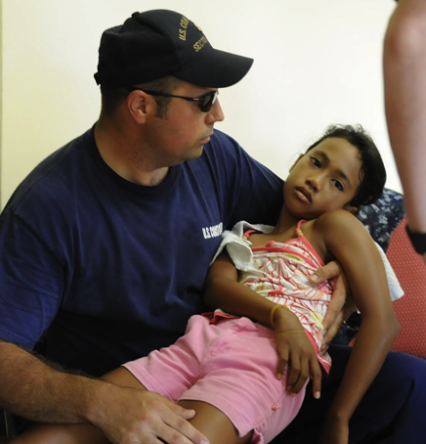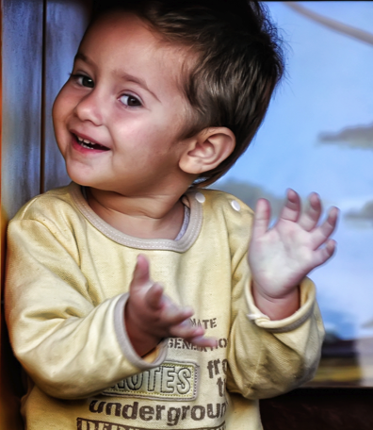

We want to understand more about what is making you unwell so that we can help other children like you. To help us find out more about what is making you and other children unwell. First we will collect data from your medical records, including medication taken and laboratory results. Secondly, we will also take some extra samples of blood and other samples while you are in hospital. All information will be studied anonymously and nobody will know is from you.

Samples of poo (stool), wee (urine), snot (nasal aspirate) and cough spit (phlegm) will also be collected when you make them.

**Cartoon information sheet for discussing ISARIC/WHO CCP study with young children**

Blood samples will be taken by finger prick or existing lines.  
The sample will be small. Numbing cream can be used.

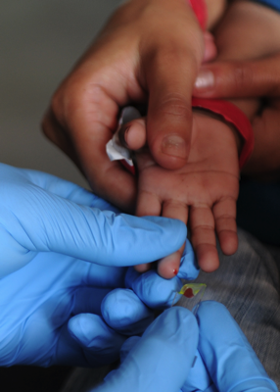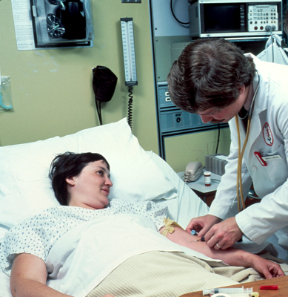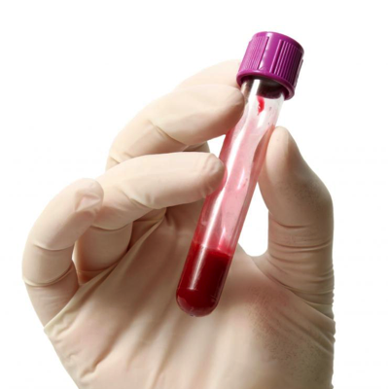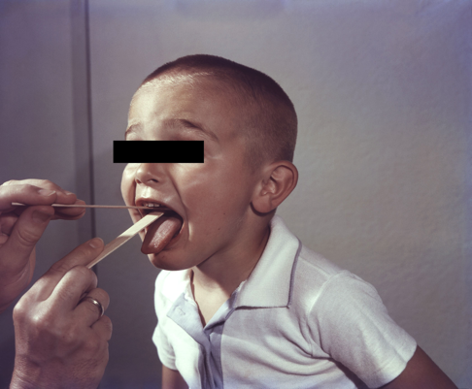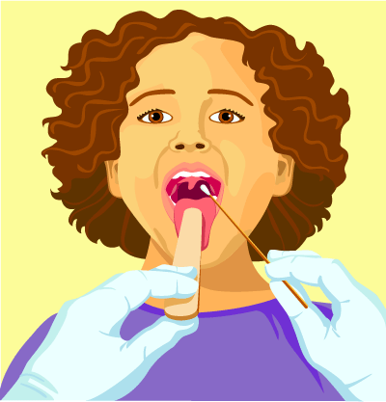

Throats will be wiped (swabbed) using cotton buds  
This does not hurt, but can tickle a bit.